Anoka Faruqee and Michelle Grabner

September 18, 2017

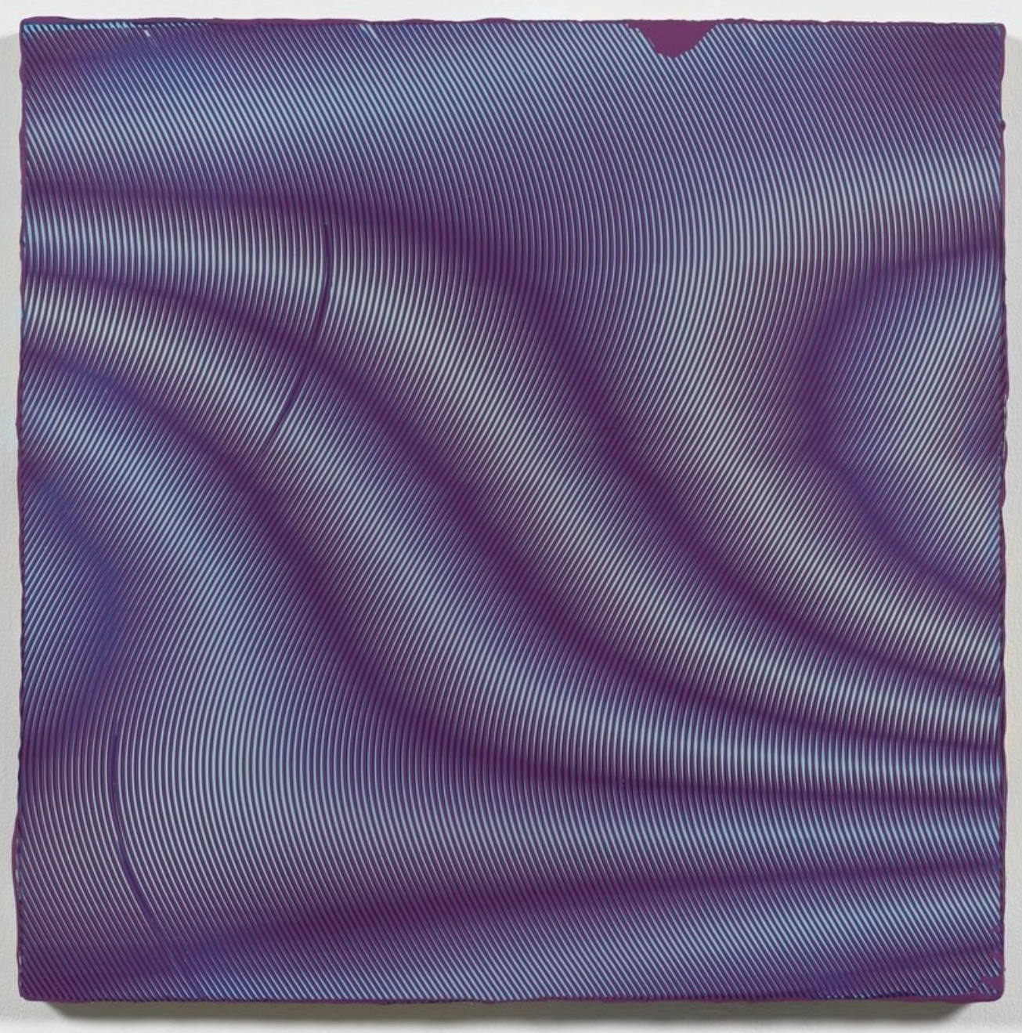
Anoka Faruqee, 2016P-16 (Wave), 2016, acrylic on linen on panel, 22.5 × 22.5 inches. Photos by Jeffrey Sturges. Images courtesy of the artist and Koenig & Clinton, Brooklyn.
There are many reasons why I wanted to have a conversation with Anoka Faruqee—perhaps the most obvious is that we share principles, philosophical and otherwise, that stem from certain repetitive and indexical processes within the language of abstraction. Given our unsteady era of reactionary politics, I was also keen to speak to another longtime artist-educator about progressive approaches in the classroom. The resulting discussion—we spoke on the phone between Milwaukee and Connecticut—moves between our work in public and institutional settings, and then almost as counterpoint, to the private and permissive world of the studio. We tried to both dig down and step back—positions we recognize to be the obligation of our métier. —Michelle Grabner
Anoka Faruqee Are you in your studio?

Michelle Grabner Yes, in a new studio. My husband and I built it last year when we moved back to Milwaukee after twenty years in Chicago. One reason for our return is that we found this odd little modernist home designed by Frank Lloyd Wright’s engineer, Mendel Glickman. It was in foreclosure. We built this studio right next door. It’s a little bit office, a little bit library, a little bit whatever. Stuff happens here. I also have a bigger painting studio in the Walker’s Point neighborhood of Milwaukee, in what used to be a print shop.

AF It’s funny you mention that because I was just thinking about how your work relates to printing. Early on, you used household objects, such as blankets and colanders, to make indexical marks onto canvases. The imprints of these three-dimensional objects created complex and morphing geometries. So I like the idea of you ending up in an old print shop, because you’ve exploited that gray area between painting and printmaking.

MG Yes, indexing by way of crude stenciling has always been a way for me to achieve that sweet spot between abstraction and representation—to have something handmade without showing the hand. And this process is absolutely in alignment with the indirectness of printmaking. I’m happy to say that when you’re in the world as an artist for a decent amount of time, the print world will eventually find you—meaning you’ll be given the chance to examine ideas of sameness, registration, and reversal in a proper print shop with the encouragement of master printers. And as an artist who values indirect methods of painting, there’re a lot of interesting things to be learned from such traditions. They just couldn’t be more fascinating. Have you worked on any print projects recently?

AF No, though the print world did try to find me. I was scheduled to do some printing at Virginia Commonwealth University’s campus in Qatar, but had to bow out since it ended up being the same year my partner and I adopted our son, Maheen. But certainly, the multiple fascinates me. And if you’re pushing up against something as a painter—whether it’s photography, printmaking, or the digital image—there’s a fear of stepping into that very thing, because your distance from it is what makes it productive.

MG I agree with exactly what you’re saying. Print-like production methods always carry a kind of philosophical discussion about originality and invention, as well as about the cultural value of such things. But the print studio itself can also yield the pleasures of simple mechanics. Here I’m thinking about the tools you might have developed to achieve your radial paintings. I’d guess the process must be at once very direct but precise and dependable, too. I have an image of one of your tools in my head, and it looks like a large wooden comb with many thick tines.

AF Very close. The tools used to make the moiré paintings are large laser-cut stainless-steel combs—each with various teeth and notches. My partner and studio collaborator, David Driscoll, devised the method of using a rake as a painting tool. Initially, they were simple tools from the hardware store used for spreading tile adhesive. But all this has to do with the matrix—by which I mean the substrate a reproducible image or object demands. The bronze sculptures of blankets you showed at James Cohan this year are cast from a mold; that’s their matrix. In printmaking, it would be the screen or plate—any object that then yields another object. This is really interesting for a painter because painting has a pretension about being its own thing. There’s this pretense of authenticity that’s both seductive and completely absurd.

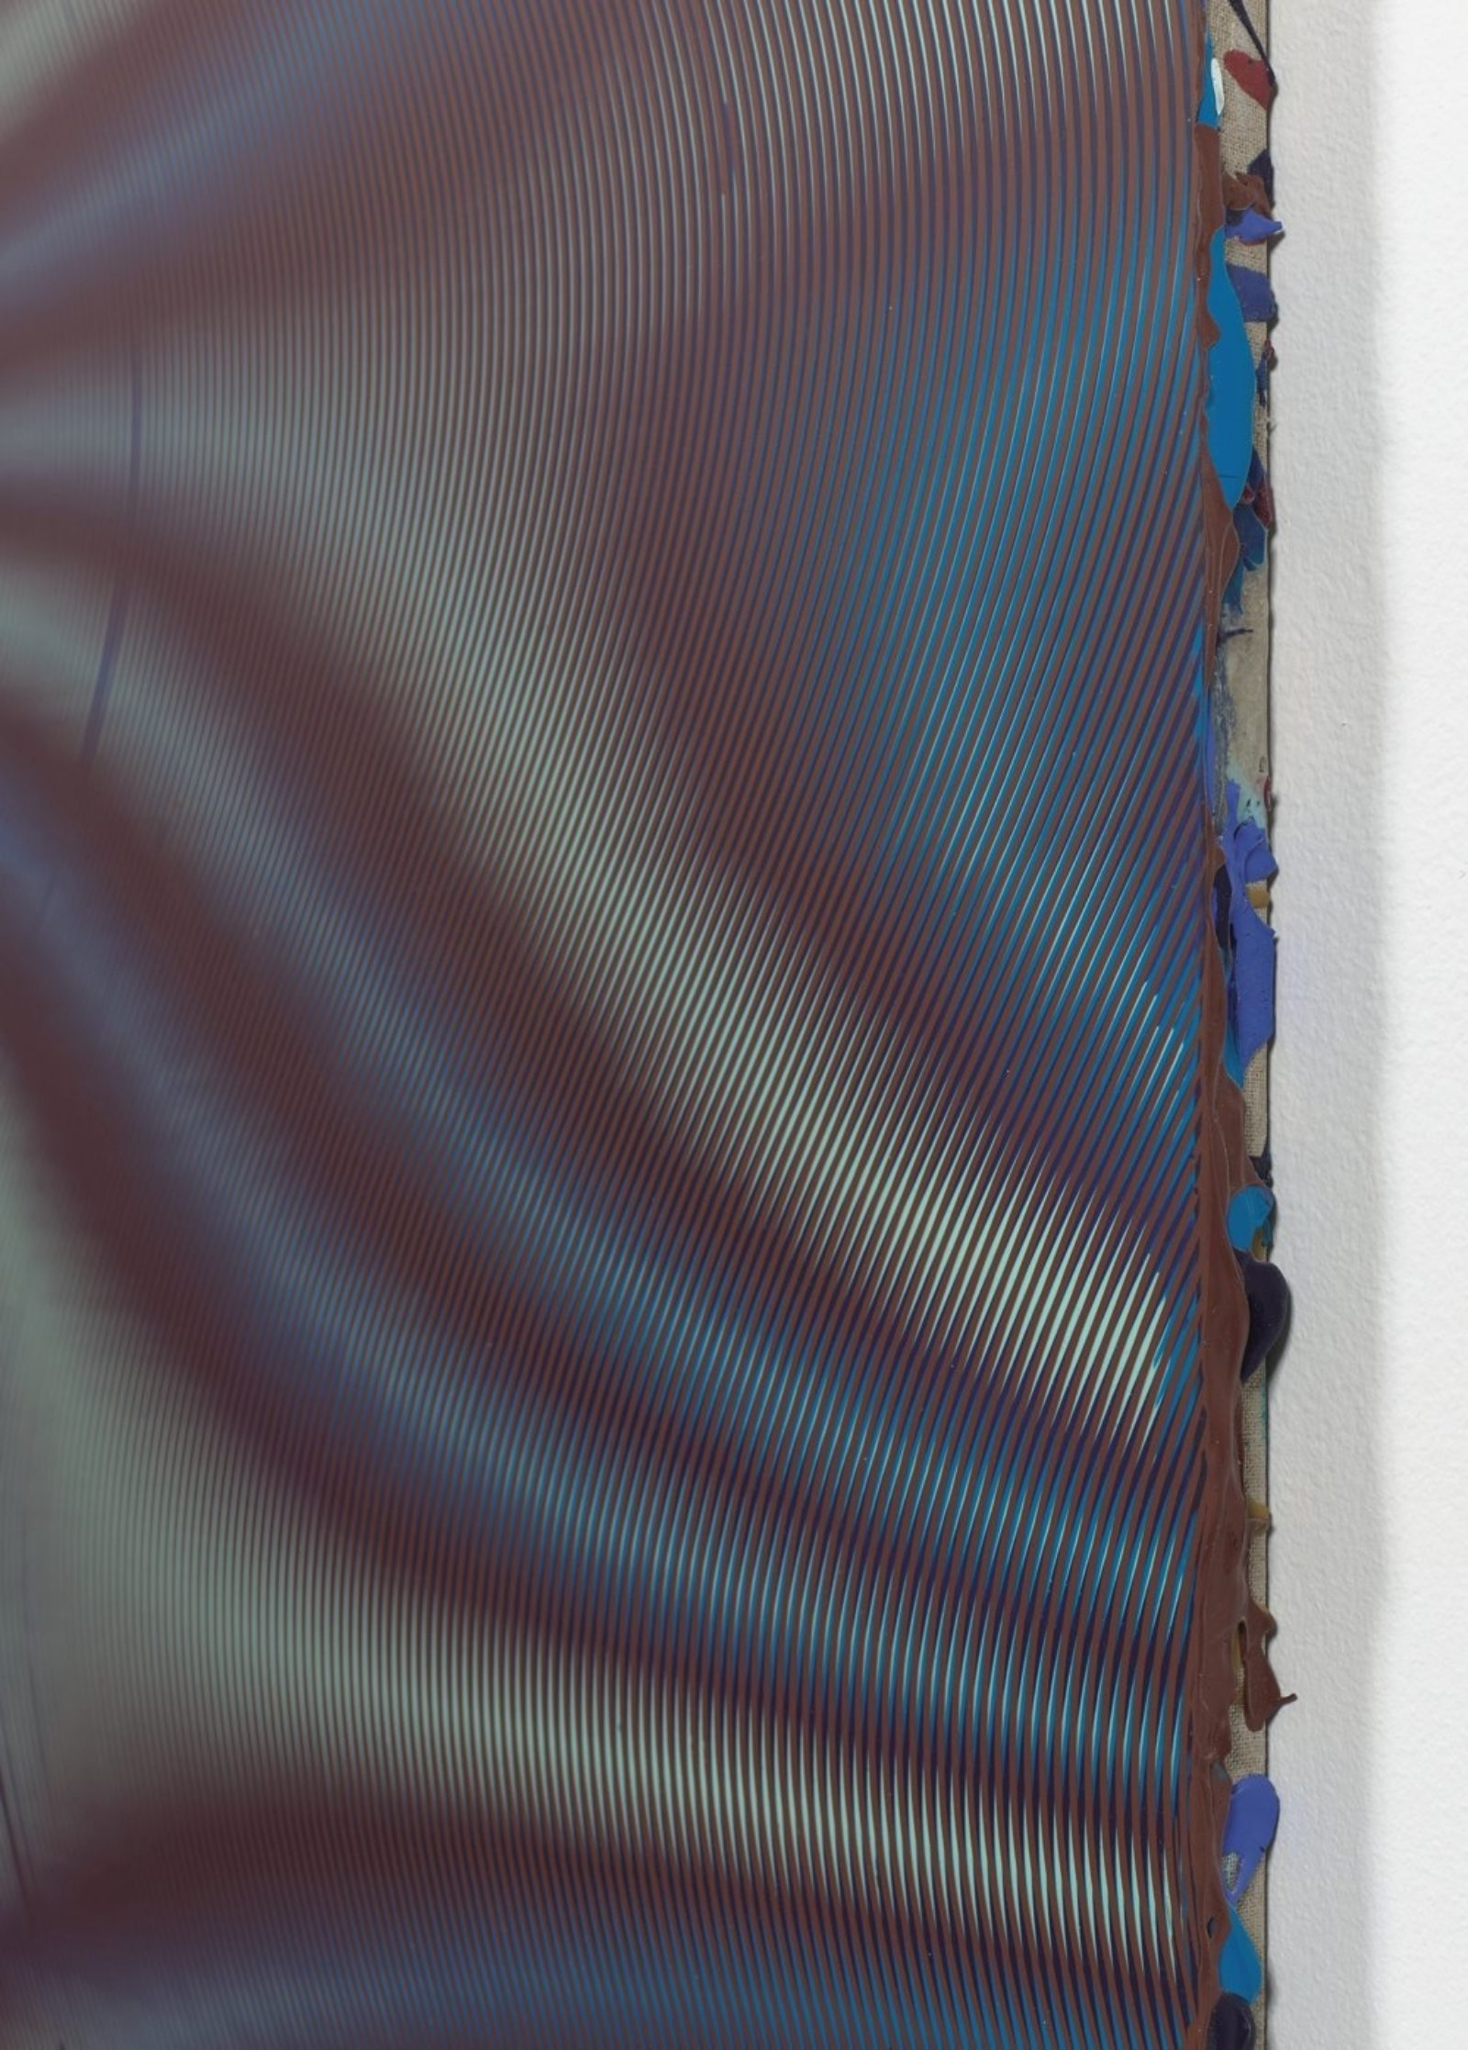
Anoka Faruqee, detail of 2016P-07 (Wave), 2016, acrylic on linen on panel, 22.5 × 22.5 inches.

MG That’s right what you say about the substrate. It’s not only the stutters, shifts, and offset marks that I gravitate to in printmaking, but also the underappreciated, laudable role of the plate or screen—or even of the ceramic shell in the foundry. But how do you negotiate this idea when you’re making your paintings?

AF That extra stuff is central to the work. There’s a universe in those errata, slips, tools, and jigs. In most instances, they’re seen as unwanted detritus, but here they become the main attraction. Moiré patterns themselves are often digital detritus. The unpredictability these elements yield makes them crucial agents of variety within an otherwise tight system. I’d guess that you’re just as invested in examining this periphery and bringing it to the center.

MG Indeed. I just reread an interview with Rebecca Morris and Laura Owens from the late ’90s—something I guest-edited for an art magazine here in Milwaukee called Art Muscle. We called the issue “LA Muscle” because Los Angeles was becoming really interesting to artists. Laura was talking about atemporality, though she didn’t call it that. Reading it over again, she seemed very concerned with being bored, or at least afraid of boring her viewers. Yet the very things she found boring, such as these invisible supports you’re talking about, are what I’ve always found most compelling. In fact, it drops me to my knees when I think about the possibilities of what can come from foundations, conventions, predictability, genres, or even boredom itself.

AF On this subject of boredom, I’m reminded of a moment in graduate school when I declared I was going to make a large painting of a houndstooth weave pattern. A friend’s response was, “No, that would be boring.” It was a provocation that stuck with me, and it has influenced the direction of my practice ever since. Laura Marks has an interesting book about the relation of Islamic aesthetics to digital technology, Enfoldment and Infinity, where she describes “transcendent infinity” and “lame infinity”—an example of the latter being the dispiriting imagining of all the computer code needed to sustain contemporary digital interfaces. So when we think about sameness and repetition, there’s always a fine line between the mundane and the sublime. Are these questions around sameness something you think about?

MG What I value about sameness is the fact that it supersedes the individual. Perhaps this corresponds with my interest in boredom.

AF My thoughts often come back to a film called A State of Mind, which was made by BBC journalists about mass games held in North Korea. These young people, many of them women, are training to do incredible gymnastic feats at the annual Arirang Festival, a huge spectacle. It’s synchronized swimming to the thousandth degree in terms of the visual and aesthetic pleasure that it yields. Obviously, there’s also something repressive about that degree of control, both bodily and institutional. It’s about the forfeiture of individuality for the sake of the state.

By contrast, we live in a highly individualistic culture, and that valorization of the individual can be at the center of both progressive and regressive thinking. I accept postmodern critiques of progress, but I still hold onto a desire for it. In terms of the studio, maybe a better way to put it is to say that the work should deepen. There are different ways to invent: there’s the person who makes many different things over time, and the person who spends a whole lifetime tinkering with a single invention—which better be a good one! (laughter)

MG And just to continue that line of thinking, perennial invention is always more desirable to late capitalism than practices that evolve slowly, steadily over the course of time.

AF Whether the studio is utopian or optimistic, you can at least determine the values that matter to you while you’re in it. Your progress as an artist may even occur by redefining these. At one point you might value a formal intricacy, and then at another you decide you’re headed for something more immediate.

MG There’s this objectionable trend in education to embracing failure. Can we talk about how the words progress and progressive are used in the studio and in contemporary art?

AF Great question. A while back, I attended a colloquium about progressive arts education at the Josef and Anni Albers Foundation. Shirin Vossoughi, a professor of learning sciences who works with the artist Walter Kitundu, said that while a lot of progressive education literature pushes the benefits of “celebrating failure,” the use of the word failure in the context of communities of color is problematic. The language around failing schools, so common in the education community, has to do with punitive metrics. For kids coming into Vossoughi and Kitundu’s Tinkering After School program from economically underprivileged communities, the idea of celebrating failure assumes a kind of privilege they may not have. So the word she preferred—and which I started to use—is draft. Her approach with the kids was to let them absorb the idea that everything is a draft, that there is always another, and that nothing is singular or conclusive.

MG It’s sobering once you start thinking about these problems of education and what they might mean. So yes, this drafting method is excellent, but I’m wondering how this idea of draft and experimentation are intertwined? I’m specifically thinking about the progressive pedagogy of Black Mountain College and the Leap before You Look exhibition at the ICA Boston last year.

AF I think that exhibition was a great reimagining of the potential of that historical moment.

MG I recently wrote a long essay for X-TRA on Leap before You Look in which I realized something startling about progressive education. Experimental education is possible only when education itself is understood as a moral entitlement. For a while now, the Right has been steadily and insidiously instilling the public consciousness with the notion that education is a privilege. Living in Wisconsin and witnessing the blatant attack by the governor and the Republican legislature on the once-esteemed UW system is distressing evidence of this political stratagem. Do you think this sort of thing changes your attitude toward teaching? I can say that in my thirty years teaching, it’s never been more ethically impactful than it is now.

AF Yes, and so many people attended Black Mountain on the GI Bill—an example of government policy that valued education as a human right. I recently did a public conversation with the curator of the Leap before You Look exhibition, Helen Molesworth, where we got tohash out the relevance of the Black Mountain project. For me, it came down to, in the broadest sense, the ethical distinction between talking the talk and walking the walk. Albers believed he was teaching individuals in the studio to walk the walk. One’s idea was only as good as it was performed—and if we could then apply this ethic to other aspects of life, then we’d all be in a better place. So that might be the potential of progressive art education: to square rhetoric and theory with action and practice.
I also think, going back to the draft, that resisting finality is more important than it’s ever been. There is such a desire to canonize, reify, or totalize. The blind spots of being an artist make it difficult to articulate a narrative around what you’re doing, because the studio is necessarily a place of searching—a place of not-knowing. This runs counter to the interpretation one presents in a lecture. You have to remind yourself, and your audience, that the form of the lecture calls for an understanding at odds with the way a studio really operates.

MG I wouldn’t continue in this profession if it came down to shaping and securing a brand. That sounds dreadful. We’re living in a moment when stories are imposed from the outside almost instantaneously. People are Instagramming from the lecture hall while you’re talking. And since so many people are developing these narratives in the vast sphere of social media, you either have to accept it—even enjoy it as some fiction that has little to do with who you are and what you do—or try to ignore it. I know several artists just a bit older than me who came to success early on in their careers, when they still had the ability to control the language around their work and individual identities. Now these same artists are miserable because they can’t do that anymore. They see it undone every time they google their name. It drives them batty and, for some, it affects their work. I’m empathetic to their reaction, but I’m also happy to be on the other side of this paradigm shift.

AF It provides a critique of authorship that runs, in many ways, parallel to what your paintings are doing with indirect mark-making and questioning what painting is. I see in your work a resistance to painting as a rarefied art object. I see it integrated into your life and domestic space—into textiles, and all decorative forms and histories. The process of making this work mirrors the questioning of the author as the source of unique, inspired, and authentic marks. So speaking about art with less finality feels consistent with your way of working.

MG That’s right. Although, to be perfectly frank, I often think the psychology of all this is messier. One starts thinking about the historical powerlessness of a woman’s relationship to painting. Even in academia, there’s a sense of illegitimacy that still pulses through me. How one thinks about language and authorship—it quickly gets complicated and harder to articulate as I come to understand these things as shaped by an ever-changing muddle of subjective and cultural forces.

AF It goes back to what we were saying about the word failure, and who’s allowed to fail, and who’s allowed to use that word in an affirmative way. The same applies to how we talk about the experience of nonknowledge in the studio. It’s a space that’s important to protect because it promotes discovery and surprise. So the question of who is allowed to claim this nonknowledge without being attacked is key. It’s possible that when men embrace not knowing, they are perceived as open-minded and confident, and when women embrace not knowing, they are perceived as… well, just not knowing.

MG Let’s circle back to your work for a bit. Can you talk about the way you were framing questions about technology and reproduction, modularity and sameness—perhaps specifically in the new paintings in your recent show at Koenig & Clinton? I’ve been thinking about the fact that painting genres set up an agreement between the artist and viewer. Does this have anything to do with your ideas about technology, repetition, and sameness?
AF It does. The most recent works at Koenig & Clinton dial in on the potential of minute misalignments between nearly identical layers, which can yield radically different effects. The fact that these are abstract paintings on linen, with dripped paint revealed along their edges, sets up an expectation that is thwarted when you confront the front surfaces, which are milled down and flat, screenlike, but with a certain physicality of layers casting faint shadows.
But early on, for me, this relationship to technology came through textiles. I spent a lot of time in fabric stores, gravitating toward patterns. That houndstooth painting was weaving turned into image. When I made it, I realized it was digital. Later, I learned about the historical connections between textiles and early computing technologies—for example, computer punch cards, which were used to program computers up until the 1970s, were first developed in the eighteenth century with the invention of mechanical looms.

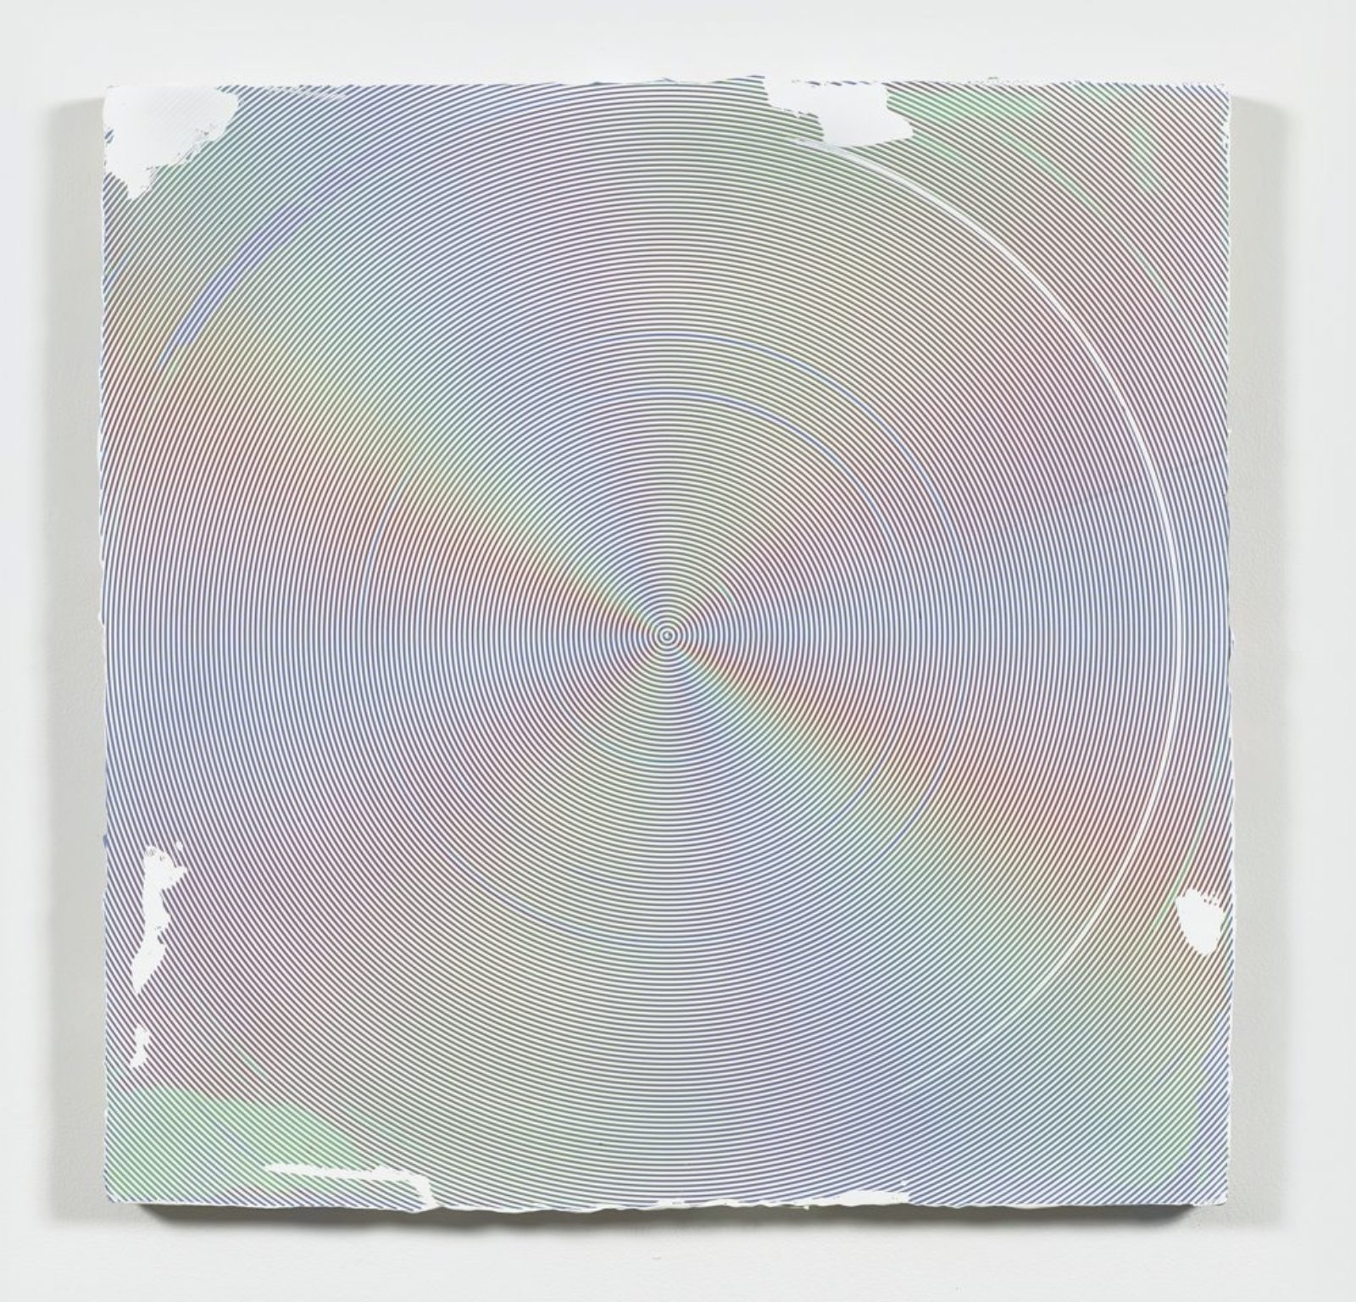
Anoka Faruqee, 2016P-09 (Circle), 2016, acrylic on linen on panel, 33.75 × 33.75 inches

MG I’m more and more delighted as we talk because I’m starting to see that we’ve been walking parallel paths. I’ve been thinking about gingham recently and its relationship to the cliché, and about how it migrates through economic classes and represents something both material and imagistic. But let me turn this around: How much does painting have to do with your work? In other words, where is the idea of painting weighted in your paintings? I often think the abstract painters most important to me are hamstrung by just how tightly they hold on to the traditional authority of the language.

AF Well, what I find myself thinking about is how work originates from some kind of unspoken pleasure. At some point, you stop fighting such proclivities and say, “That’s who I am, and it gives me a lot of pleasure.” As you start to unpack that, you find it’s actually bigger than individual desire: it’s cultural desire. Some of these desires—for order, rainbows, sunsets, gingham, or houndstooth—are expressed in cultural clichés. The reason I gravitated toward painting—and maybe you feel this, too—is that it is limited in this regard. It has boundaries and a shape. Obviously, you’ve played with these constraints. You’ve made circular paintings and things not considered paintings at all, and also played with the way rectangular things are installed. I’m thinking of your 2014 exhibition at James Cohan, where you displayed your woven collages overlapped on a low platform, alongside paintings on a wall and a large composite object hanging from a ceiling. But at the same time, you participate in painting conventions. It feels like you always come back to painting as you move away from it.

For me, teaching is the place where I talk about things outside of painting. Our studio operates on a depth model, sometimes at the expense of breadth. Most of my students understand breadth; they’re very comfortable moving between media, ideas, and topics. But they have a harder time hunkering down on something. So I’m often saying, “Hey, why don’t you just linger with that a little?” That’s the challenge: finding the balance between breadth and depth, because I think we all need both.

MG Both at different times and in different contexts.

AF You certainly have this amazing breadth in your relationship to community, to arts communities, whether it’s curating the 2014 Whitney Biennial or a regional biennial in Portland, Oregon. The ability to go between these art spaces is very rare. People generally choose. “This is my art world,” they say, and then stay there. You really move between different roles, too: writing, curating, teaching, and making work. So it makes sense to me that when you’re in your studio, you’re like, “Okay, we can revisit. We can dwell.” I like the word dwell because it speaks to the idea of home, and it suggests how dwelling is both a verb and a noun, and how these are interconnected. It’s the impulse to hunker down and nest in a practice.

MG I’ve been writing and thinking a lot about Maintenance Art, Mierle Laderman Ukeles’s recent show at the Queens Museum. I’ve been considering how practices of care and maintenance could be engaged now. It’s interesting to think about the question of progress—to come back to that notion—in relation to the fact that she was writing her manifesto around the same time NASA had sent back images of Earth as seen from the moon. We didn’t yet really understand the wholeness and vulnerability of our planet until we saw those images. It’s at that point in time that she sat down to write her manifesto, understanding family care and domestic maintenance as art, while thinking about garbage, refuse, and municipal maintenance as art, too. That swing is really extraordinary to me and makes a lot of sense. Of course, at the same time Ukeles’s and the environmental movement emerged, there were others who looked at those NASA images and saw the potential of global exploitation.

AF Those NASA images make me think of your investment in “field” painting, and about how the presentation of the field omits scale. It can alternately be something very small or very vast. With the tondo paintings you make, there was an intimate starting point—a one-toone scale with the etched or drawn-in line that yields something potentially much more spatial and vast. There’s a correlation between what you’re saying about Ukeles’s work and the idea that the local—what’s most intimate and day to day—can turn into a much larger network.

MG In that vein, Ukeles believed institutions were necessary for platforming and legitimizing both her actions and beliefs. Theoretical positions, and the institutions that host them, for me anyway, should be balanced with local actions and the studio practice. I’m just starting to read some theories on new institutionalism that optimistically look at the cultural potential in the slow rates of change specific to them.

AF On a purely pragmatic level, we need institutions. We need government and laws. But they’re failing us right now.

MG I think we simply don’t have the patience, so we neglect them. It’s their timeframe. They’re ships that move slowly, while the rest of the world moves at hyperspeed. But that’s where institutions can help us to experience different time relationships to cultural ideas.

AF This reminds me of when, as one of the curators of a Whitney Biennial, you spoke about wanting to highlight abstraction. Do you think what we’ve been talking about today is related to abstraction? Why did you gravitate toward it?

MG First of all, abstract painting is in my wheelhouse. I think about it all the time, inside and outside the studio. For the 2014 Whitney Biennial, I wanted to align its authority with a handful of committed female artists working in the discipline. And to be clear, painting, particularly abstraction, does retain some cultural authority. I can tell you that one of my cocurators for the biennial was deeply troubled by my plan to install large-scale abstract painting on the fourth floor, as it had been transformed into a performance space for the 2012 Biennial. It wasn’t a matter of presenting a theoretical framework around contemporary abstraction but instead a survey of influential practices at that time.
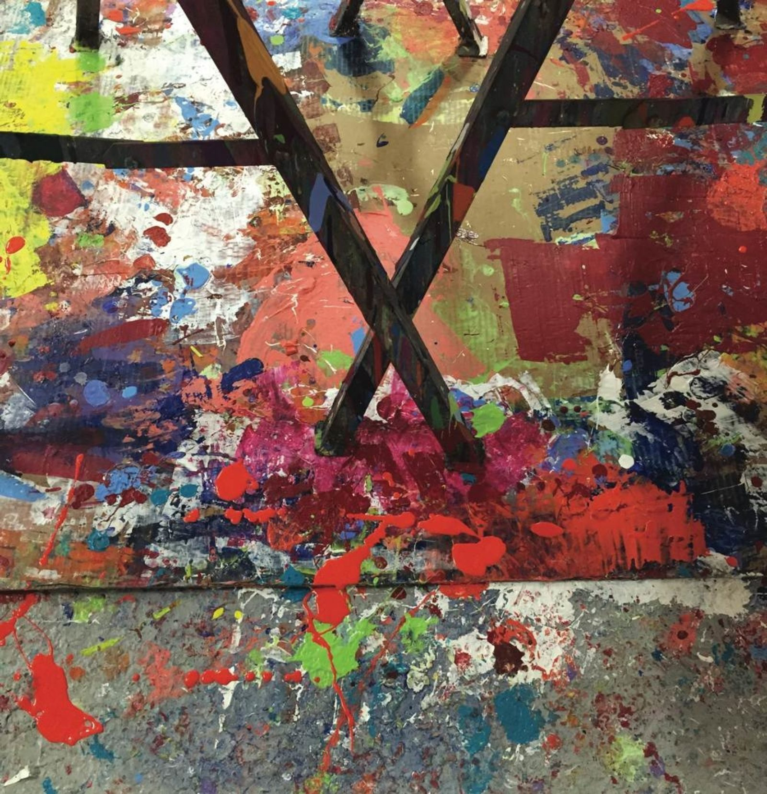
The floor of Faruqee’s studio in New Haven, Connecticut, 2017. Photo by David Driscoll. Courtesy of the artist.

AF Given what’s happening in the world and where the art market is, abstraction is too easily lumped in with a zombie formalism that caters to market demand. But I hope another motivation for formal abstraction is still possible. To return to Albers, that the how might generate as much meaning as the what was the hope and desire of early twentieth-century European abstraction brought to the States in large part via Black Mountain College. Far more direct address and action is possible with more narrative-based practices. Working with abstraction, you lose a lot of people in the conversation.

MG It’s true, but over the years that bothers me less and less. The things we’ve been talking about—repetition, time, sameness, and difference—are themes in contemporary life. Abstraction requires complex interpretation, and I feel that, though the material turn in painting is compelling, even sophisticated critics too often dismiss formalism. This drives me nuts. Form is always about order, and order is always political.

AF I agree. You’re talking about the ability to analyze and be critical, and we’re seeing an assault on that. That’s the value of the studio and classroom—an ability to create a set of outcomes you determine, or a set of values you pursue that can later be questioned or challenged. It’s not about achieving fixed goals. When you’re putting together a Lego set, you don’t have to follow the picture, though that’s been the trend for a while now. Whatever happened to building your own crazy forms?

MG I think you hit the nail on the head.

Anoka Faruqee is a painter who lives in New Haven and Brooklyn. She is the director of graduate studies in painting and printmaking at Yale University. Faruqee’s work has been exhibited at venues including Secession in Vienna, MoMA PS1, Albright-Knox Gallery in Buffalo, and Bjorkholmen Gallery in Stockholm, among others.

Michelle Grabner is a Wisconsin-born artist working in drawing, painting, video, and sculpture. She is a professor of painting and drawing at the School of the Art Institute of Chicago. She co-curated the 2014 Whitney Biennial with Anthony Elms and Stuart Comer. Solo exhibitions of her work have been held at the Museum of Contemporary Art Cleveland, the Indianapolis Museum of Art, and the University Galleries of Illinois State University, among others.

