The Truth is Out There: Anoka Faruqee at Hosfelt Gallery

November 24, 2013
Written by Elspeth Walker
Anoka Faruqee‘s current show at Hosfelt Gallery, The Sum is Greater Than Its Parts, is the result of a year-long meditation on the kind of Moiré patterns – the patterns that result from placing one semitransparent object with a repetitive pattern over another – that occur via hyper-proximity to the digital.
Faruqee’s paintings are constructed using “comb-like notched trowels” that she pulls through wet paint, “kind of like raking sand in a zen garden.” (1) As the layers of colors interact, they form the optical interference that creates the Moiré pattern. Though the paintings are technically done free-hand, Faruqee’s comb tool directs her designs and makes them appear digitally constructed. The tool creates a kind of rudimentary cyborg relationship that is responsible for the work. However, Faruqee has pointedly left behind many “mistakes” that become traces of the artist’s presence. For instance, she does not tape off the canvas’ edges and there are places where her paints do not match up perfectly near the edges of her patterns.

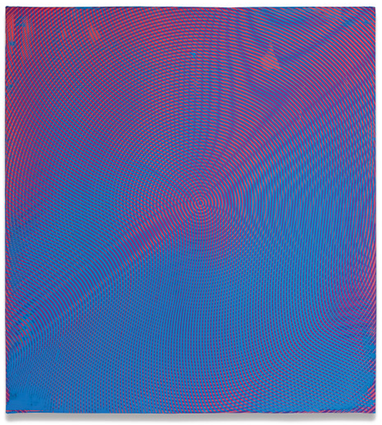
Usually considered glitches, Moiré patterns are the often undesired artifacts of images produced by computer graphic techniques. Faruqee’s inability to create wholly perfect patterns thus becomes a part of the Moiré algorithm: mistakes within a mistake. Deviance becomes a part of the form, as these moments of error remain dedicated gestures in the focused pursuit of a calculated pattern. Faruqee’s practice reflects on the desire for perfection and the subsequent, inevitable falling-short, amassing a grouping of micro-failures that collectively push the work towards the “Whole” referenced in the exhibition’s title.

Most of Faruqee’s canvases range from 11.25 x 10.5 inches to 22.5 x 20.5 inches; these dimensions allow for a large white space surrounding the images which seems to crop the paintings into extreme close-ups of some screen, somewhere. Her perfect squares appear as cutouts, little keys to some absent larger image. Whatever it is we are looking at, Faruqee positions us far too close to decipher the whole from which this part is derived. The paintings allude to the promise of a far-off screen that hosts an image we might rationally understand. Totality lives out of reach, perpetually housed in the beyond.

Faruqee’s paintings lend themselves to a kind of theoretical discourse that can become exhausting. There is so much to say about the work that it’s possible to bypass the emotional texture of the initial aesthetic encounter. As Faruqee’s paintings rest on the edge of perception, it feels natural to want to talk about them too much – to try and make sense of them, to compensate for the optical breakdown intrinsic to her Moiré patterns. But Faruqee’s work is most exciting when it inspires intangible, impossible personal memories of the digital. When I look at the photographs I took on my iPhone of her paintings, I feel an emotional twinge. I sense some wisp of memory, some recollection of something I might have reacted to on a screen, once – though I cannot remember it.

The digital precludes the possibility of touch. As we are physiologically and emotionally never able to fully grasp what we are observing, the optical illusion of the Moiré inspires a kind of tragic distance. Faruqee’s meditative, fluid practice of control, and the subsequent theorizing that surrounds her work, results in crisis as we recognize our inability to perceive. These paintings should remain mysterious, quiet, liminal: perfect glitches that signify some truth, “out there,” forever beyond our reach.

The Sum is Greater Than Its Parts is on view at Hosfelt Gallery through December 29

